|  |  |
| --- | --- |
| Simulation of heat conduction  Using Matlab and Python | HOME ASSIGNMENT: 2020  d2θ/dx2 –m2 θ=0  The present work shows the inﬂuence of the mutual heat transfer on the eﬀecti-  RISHAV KUMAR  511017068@Dy |

Modelling and Simulation Lab

Python & Matlab Assignment

RISHAV KUMAR

511017068

Question: 1( a ) Snap Sort from text editor Geany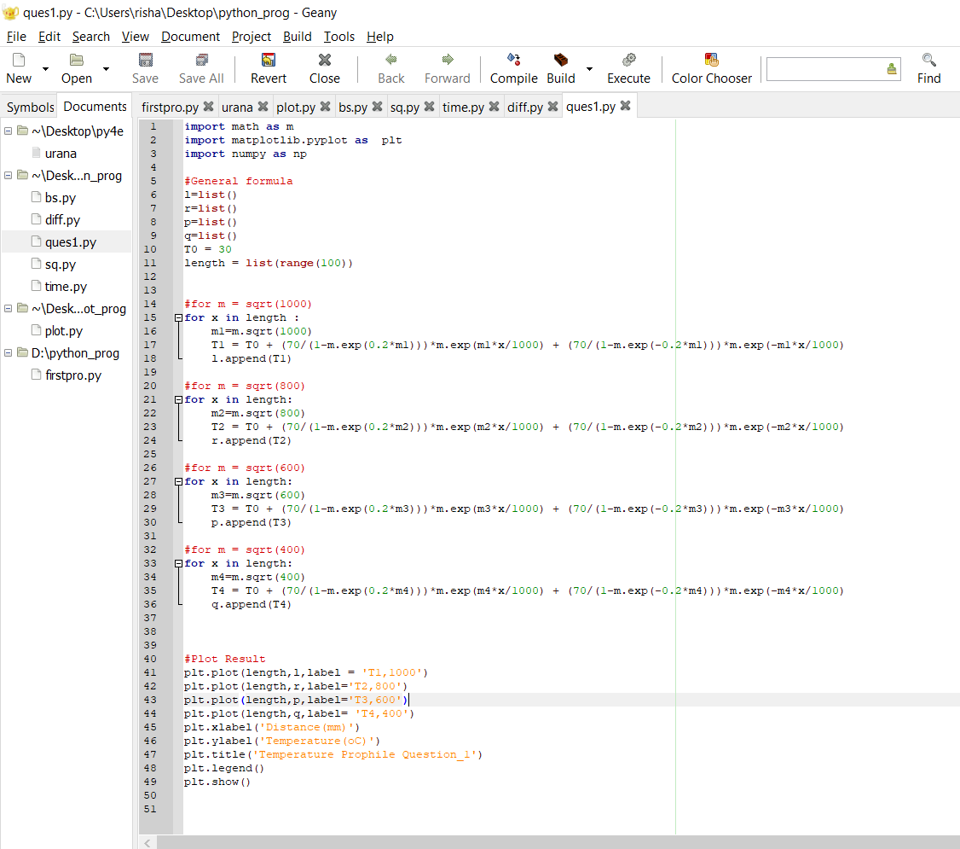

Source code:Question 1( a )

import math as m

import matplotlib.pyplot as plt

import numpy as np

#General formula

l=list()

r=list()

p=list()

q=list()

T0 = 30

length = list(range(100))

#for m = sqrt(1000)

for x in length :

m1=m.sqrt(1000)

T1 = T0 + (70/(1-m.exp(0.2*m1)))*m.exp(m1*x/1000) + (70/(1-m.exp(-0.2*m1)))*m.exp(-m1*x/1000)

l.append(T1)

#for m = sqrt(800)

for x in length:

m2=m.sqrt(800)

T2 = T0 + (70/(1-m.exp(0.2*m2)))*m.exp(m2*x/1000) + (70/(1-m.exp(-0.2*m2)))*m.exp(-m2*x/1000)

r.append(T2)

#for m = sqrt(600)

for x in length:

m3=m.sqrt(600)

T3 = T0 + (70/(1-m.exp(0.2*m3)))*m.exp(m3*x/1000) + (70/(1-m.exp(-0.2*m3)))*m.exp(-m3*x/1000)

p.append(T3)

#for m = sqrt(400)

for x in length:

m4=m.sqrt(400)

T4 = T0 + (70/(1-m.exp(0.2*m4)))*m.exp(m4*x/1000) + (70/(1-m.exp(-0.2*m4)))*m.exp(-m4*x/1000)

q.append(T4)

#Plot Result

plt.plot(length,l,label = 'T1,1000')

plt.plot(length,r,label='T2,800')

plt.plot(length,p,label='T3,600')

plt.plot(length,q,label= 'T4,400')

plt.xlabel('Distance(mm)')

plt.ylabel('Temperature(oC)')

plt.title('Temperature Distribution Ques_1(a)')

plt.legend()

plt.show()

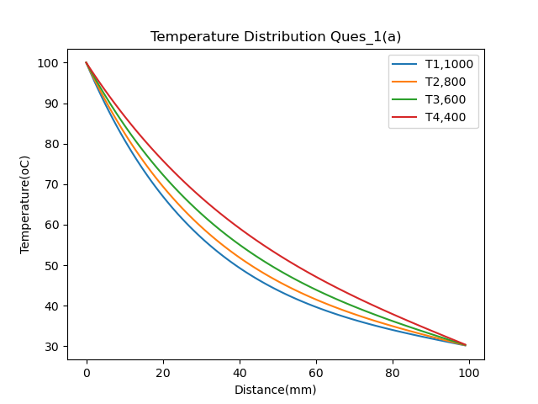

Question: 1( b ) Snap Sort from text editor Geany

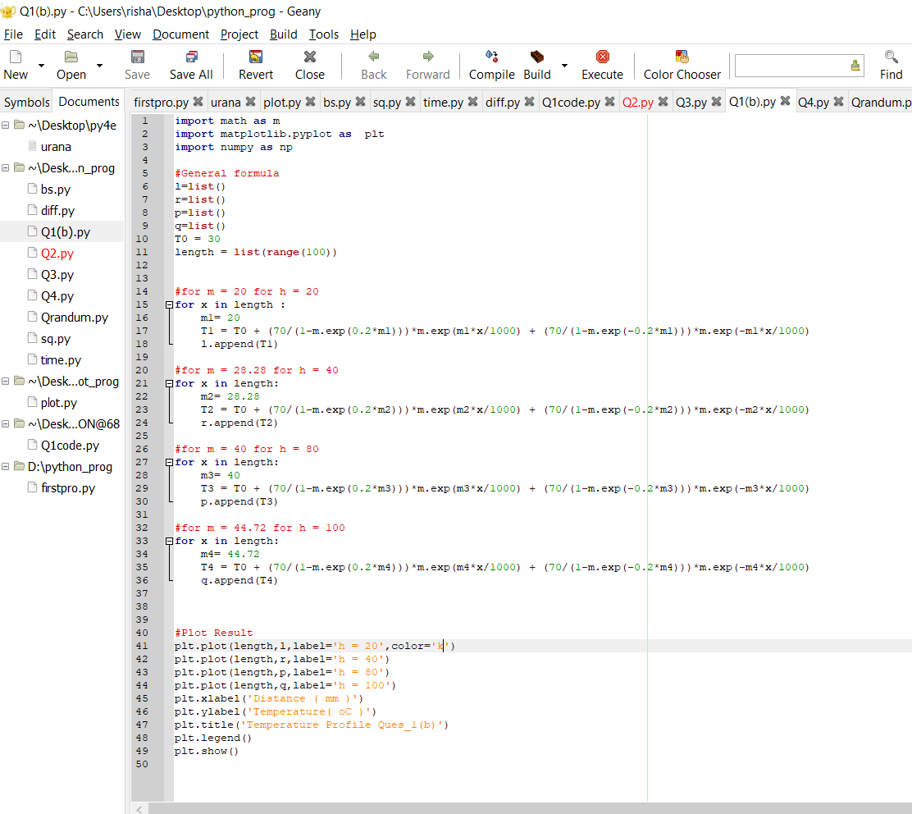

Source code:Question 1( b )

import math as m

import matplotlib.pyplot as plt

import numpy as np

#General formula

l=list()

r=list()

p=list()

q=list()

T0 = 30

length = list(range(100))

#for m = 20 for h = 20

for x in length :

m1= 20

T1 = T0 + (70/(1-m.exp(0.2*m1)))*m.exp(m1*x/1000) + (70/(1-m.exp(-0.2*m1)))*m.exp(-m1*x/1000)

l.append(T1)

#for m = 28.28 for h = 40

for x in length:

m2= 28.28

T2 = T0 + (70/(1-m.exp(0.2*m2)))*m.exp(m2*x/1000) + (70/(1-m.exp(-0.2*m2)))*m.exp(-m2*x/1000)

r.append(T2)

#for m = 40 for h = 80

for x in length:

m3= 40

T3 = T0 + (70/(1-m.exp(0.2*m3)))*m.exp(m3*x/1000) + (70/(1-m.exp(-0.2*m3)))*m.exp(-m3*x/1000)

p.append(T3)

#for m = 44.72 for h = 100

for x in length:

m4= 44.72

T4 = T0 + (70/(1-m.exp(0.2*m4)))*m.exp(m4*x/1000) + (70/(1-m.exp(-0.2*m4)))*m.exp(-m4*x/1000)

q.append(T4)

#Plot Result

plt.plot(length,l,label='h = 20',color='k')

plt.plot(length,r,label='h = 40')

plt.plot(length,p,label='h = 80')

plt.plot(length,q,label='h = 100')

plt.xlabel('Distance ( mm )')

plt.ylabel('Temperature( oC )')

plt.title('Temperature Profile Ques_1(b)')

plt.legend()

plt.show()

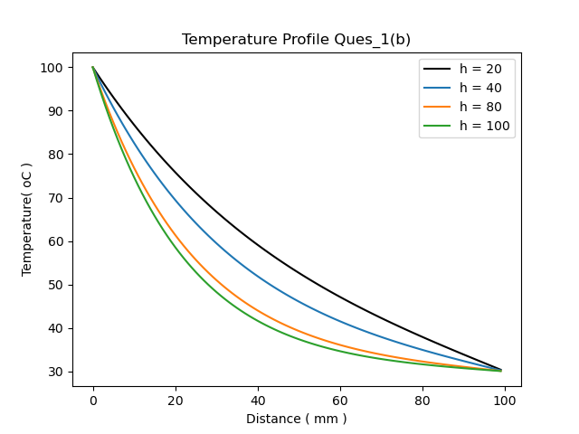

Question: 2 Snap Sort from text editor Geany

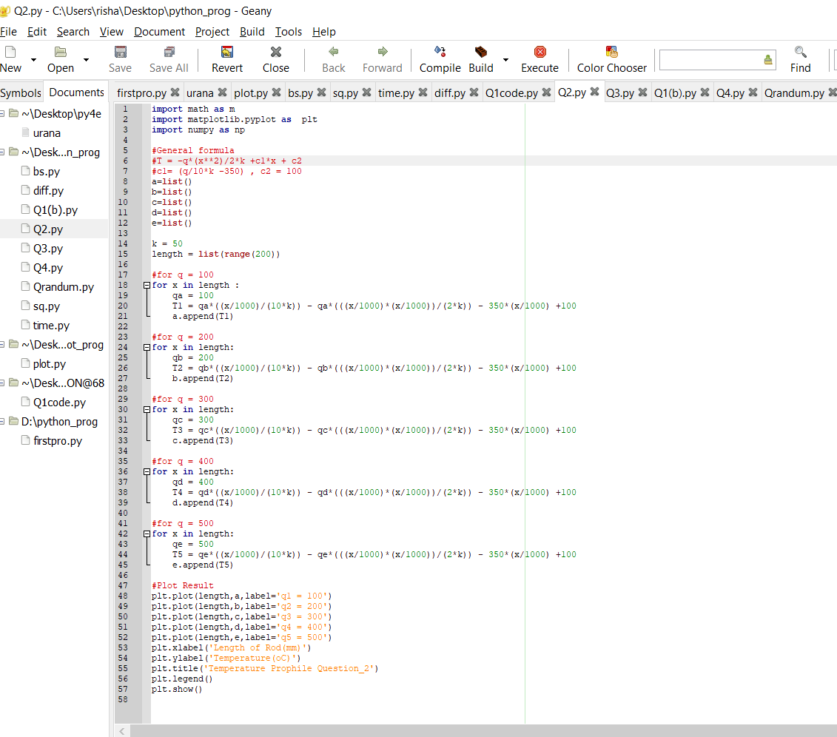

Source code:Question 2

import math as m

import matplotlib.pyplot as plt

import numpy as np

#General formula

#T = -q*(x**2)/2*k +c1*x + c2

#c1= (q/10*k -350) , c2 = 100

a=list()

b=list()

c=list()

d=list()

e=list()

k = 50

length = list(range(200))

#for q = 100

for x in length :

qa = 100

T1 = qa*((x/1000)/(10*k)) - qa*(((x/1000)*(x/1000))/(2*k)) - 350*(x/1000) +100

a.append(T1)

#for q = 200

for x in length:

qb = 200

T2 = qb*((x/1000)/(10*k)) - qb*(((x/1000)*(x/1000))/(2*k)) - 350*(x/1000) +100

b.append(T2)

#for q = 300

for x in length:

qc = 300

T3 = qc*((x/1000)/(10*k)) - qc*(((x/1000)*(x/1000))/(2*k)) - 350*(x/1000) +100

c.append(T3)

#for q = 400

for x in length:

qd = 400

T4 = qd*((x/1000)/(10*k)) - qd*(((x/1000)*(x/1000))/(2*k)) - 350*(x/1000) +100

d.append(T4)

#for q = 500

for x in length:

qe = 500

T5 = qe*((x/1000)/(10*k)) - qe*(((x/1000)*(x/1000))/(2*k)) - 350*(x/1000) +100

e.append(T5)

#Plot Result

plt.plot(length,a,label='q1 = 100')

plt.plot(length,b,label='q2 = 200')

plt.plot(length,c,label='q3 = 300')

plt.plot(length,d,label='q4 = 400')

plt.plot(length,e,label='q5 = 500')

plt.xlabel('Length of Rod(mm)')

plt.ylabel('Temperature(oC)')

plt.title('Temperature Prophile Question_2')

plt.legend()

plt.show()

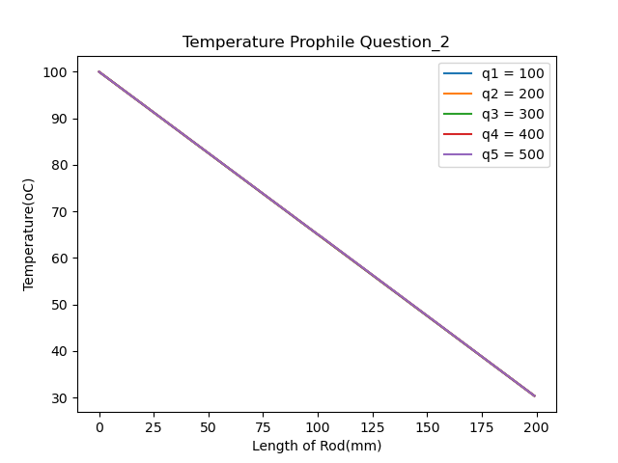

(All four plots are coincident and are shown as a subplot in above figure)

Question: 3 Snap Sort from text editor Geany

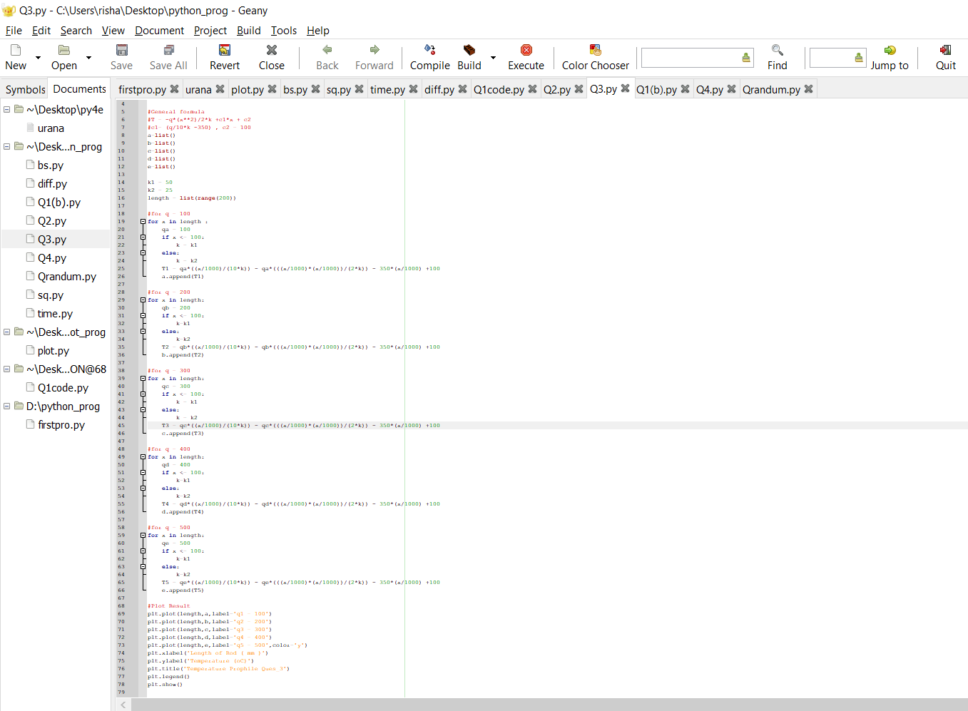

Source code:Question 3

import math as m

import matplotlib.pyplot as plt

import numpy as np

#General formula

#T = -q*(x**2)/2*k +c1*x + c2

#c1= (q/10*k -350) , c2 = 100

a=list()

b=list()

c=list()

d=list()

e=list()

k1 = 50

k2 = 25

length = list(range(200))

#for q = 100

for x in length :

qa = 100

if x <= 100:

k = k1

else:

k = k2

T1 = qa*((x/1000)/(10*k)) - qa*(((x/1000)*(x/1000))/(2*k)) - 350*(x/1000) +100

a.append(T1)

#for q = 200

for x in length:

qb = 200

if x <= 100:

k=k1

else:

k=k2

T2 = qb*((x/1000)/(10*k)) - qb*(((x/1000)*(x/1000))/(2*k)) - 350*(x/1000) +100

b.append(T2)

#for q = 300

for x in length:

qc = 300

if x <= 100:

k = k1

else:

k = k2

T3 = qc*((x/1000)/(10*k)) - qc*(((x/1000)*(x/1000))/(2*k)) - 350*(x/1000) +100

c.append(T3)

#for q = 400

for x in length:

qd = 400

if x <= 100:

k=k1

else:

k=k2

T4 = qd*((x/1000)/(10*k)) - qd*(((x/1000)*(x/1000))/(2*k)) - 350*(x/1000) +100

d.append(T4)

#for q = 500

for x in length:

qe = 500

if x <= 100:

k=k1

else:

k=k2

T5 = qe*((x/1000)/(10*k)) - qe*(((x/1000)*(x/1000))/(2*k)) - 350*(x/1000) +100

e.append(T5)

#Plot Result

plt.plot(length,a,label='q1 = 100')

plt.plot(length,b,label='q2 = 200')

plt.plot(length,c,label='q3 = 300')

plt.plot(length,d,label='q4 = 400')

plt.plot(length,e,label='q5 = 500',color='y')

plt.xlabel('Length of Rod ( mm )')

plt.ylabel('Temperature (oC)')

plt.title('Temperature Prophile Ques_3')

plt.legend()

plt.show()

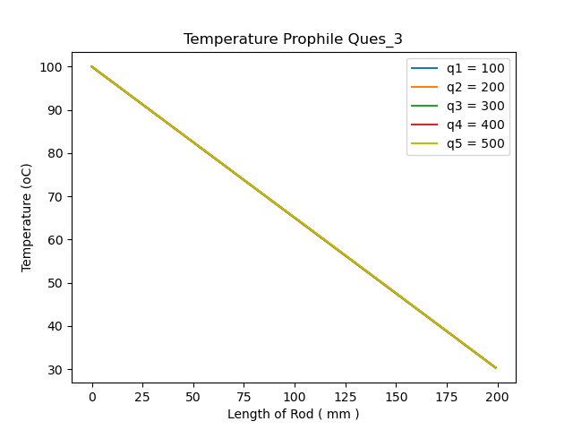 (All four plots are coincident and are shown as a subplot in above figure)

Q4a.Source Code:

clc;

clear all;

format compact;

L = 0.5;

n = 100;

Tinf = 30;

Tl = 30;

Tb = 100;

dx = L/(n-1);

alpha = input('Enter Thermal Diffusivity');

h = input('Enter h ');

k = input('Thermal Conductivity');

t_final = 120;

dt = 0.01;

x(1)= 0;

for i=2:n

x(i)=x(i-1)+dx;

end

T = ones(n,1)*T0;

T(1,1) = 100;

plot(x,T);

pause(5);

t = 0:dt:t_final;

for j = 1:length(t)

for i=2 : n-1

A(i,i)=-(2/(dx^2) + 1/alpha/dt);

A(i,i+1)=1/(dx)^2;

A(i,i-1)=1/(dx)^2;

B(i,1) = -(1/alpha/dt*T(i));

end

A(1,1) = 1;

A(n,n-1) = 1/(dx)^2;

A(n,n) = -(2/(dx^2) + 1/alpha/dt + h/k);

B(1,1) = T1;

B(n,1) = -(1/alpha/dt*T(n) + h/k*Tinf);

T=inv(A)*B;

plot(x,T);

pause(0.001);

end

THE OBTAINED PROFILES ARE AN ANIMATION.

Q4b.Source Code:

clc;

clear all;

format compact;

L = 0.5;

n = 100;

Tinf = 30;

Tl = 30;

Tb = 100;

dx = L/(n-1);

alpha = input('enter therrmal diffusivity');

h = input('enter h ');

k = input('thermal conductivity');

t_final = 120;

dt = 0.01;

T = ones(n,1)*T0;

T(1,1) = 100;

t = 0:dt:t_final;

x(1)= 0;

for i=2:n

x(i)=x(i-1)+dx;

if x(i)< 0.2

k=i;

end

end

for j = 1:length(t)

for i=2 : n-1

A(i,i)=-(2/(dx^2) + 1/alpha/dt);

A(i,i+1)=1/(dx)^2;

A(i,i-1)=1/(dx)^2;

B(i,1) = -(1/alpha/dt*T(i));

end

A(1,1) = 1;

A(n,n-1) = 1/(dx)^2;

A(n,n) = -(2/(dx^2) + 1/alpha/dt + h/k);

B(1,1) = T1;

B(n,1) = -(1/alpha/dt*T(n) + h/k*Tinf);

T=inv(A)*B;

K(j,1)=T(k);

end

time(1)= 0;

for i=2:length(t)

time(i)=time(i-1)+dt;

end

plot(time,K);

xlabel('Time');

ylabel('Temperature');

Case 1: Steel ; h = 4.2*10**(-6)

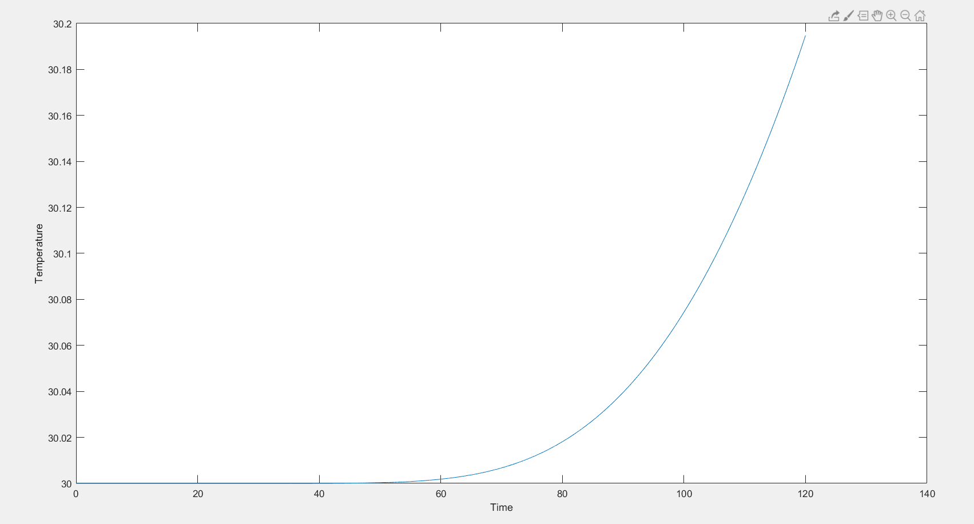

Case 2: Aluminum ; h = 9.7*10**(-5)

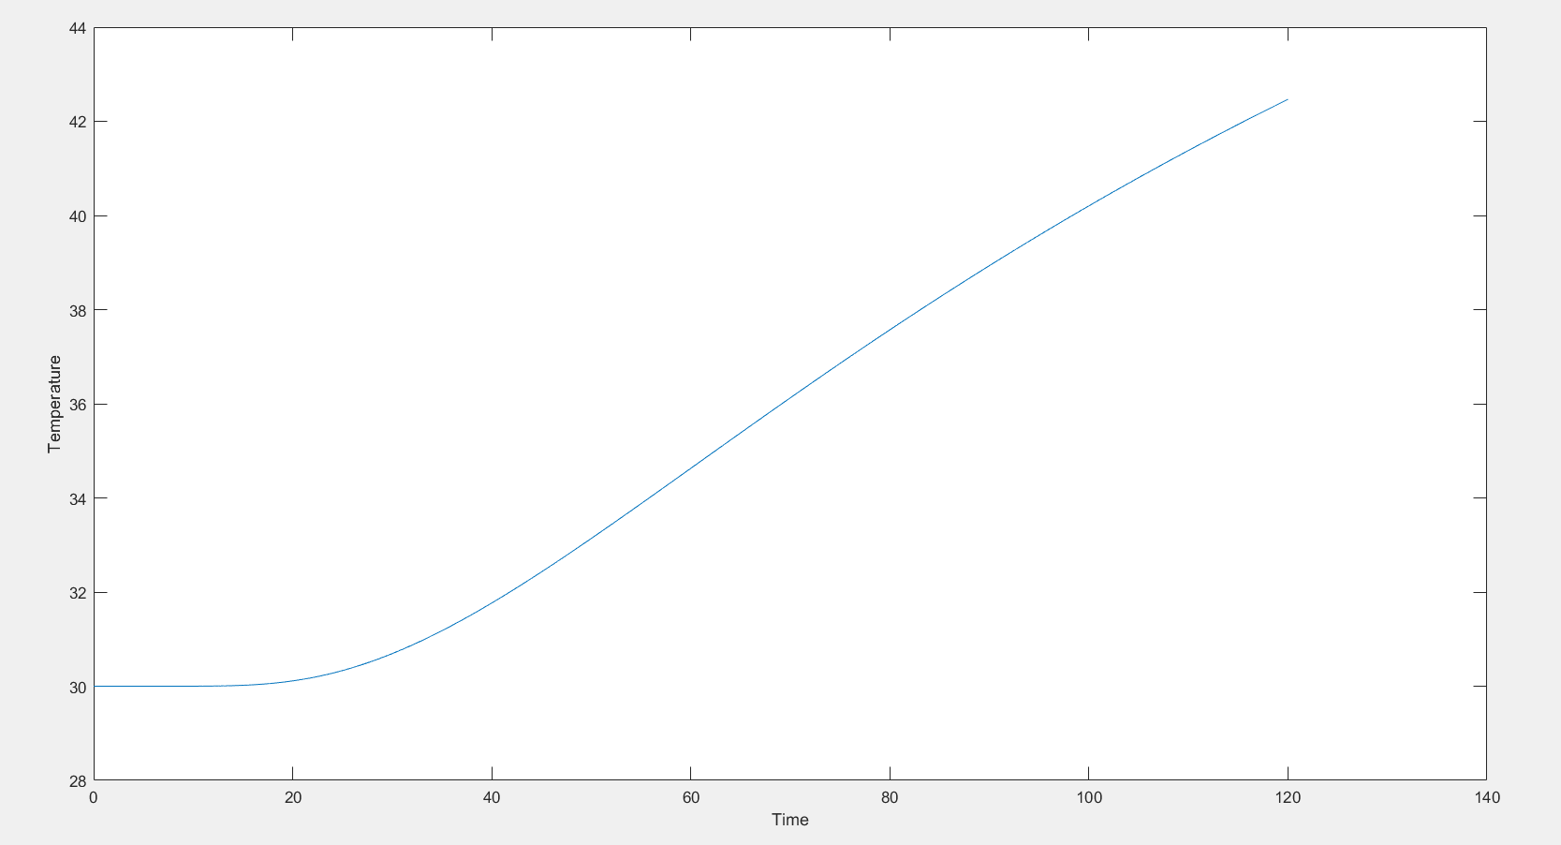

Case 3: Copper ; h = 1.11*10**(-4)

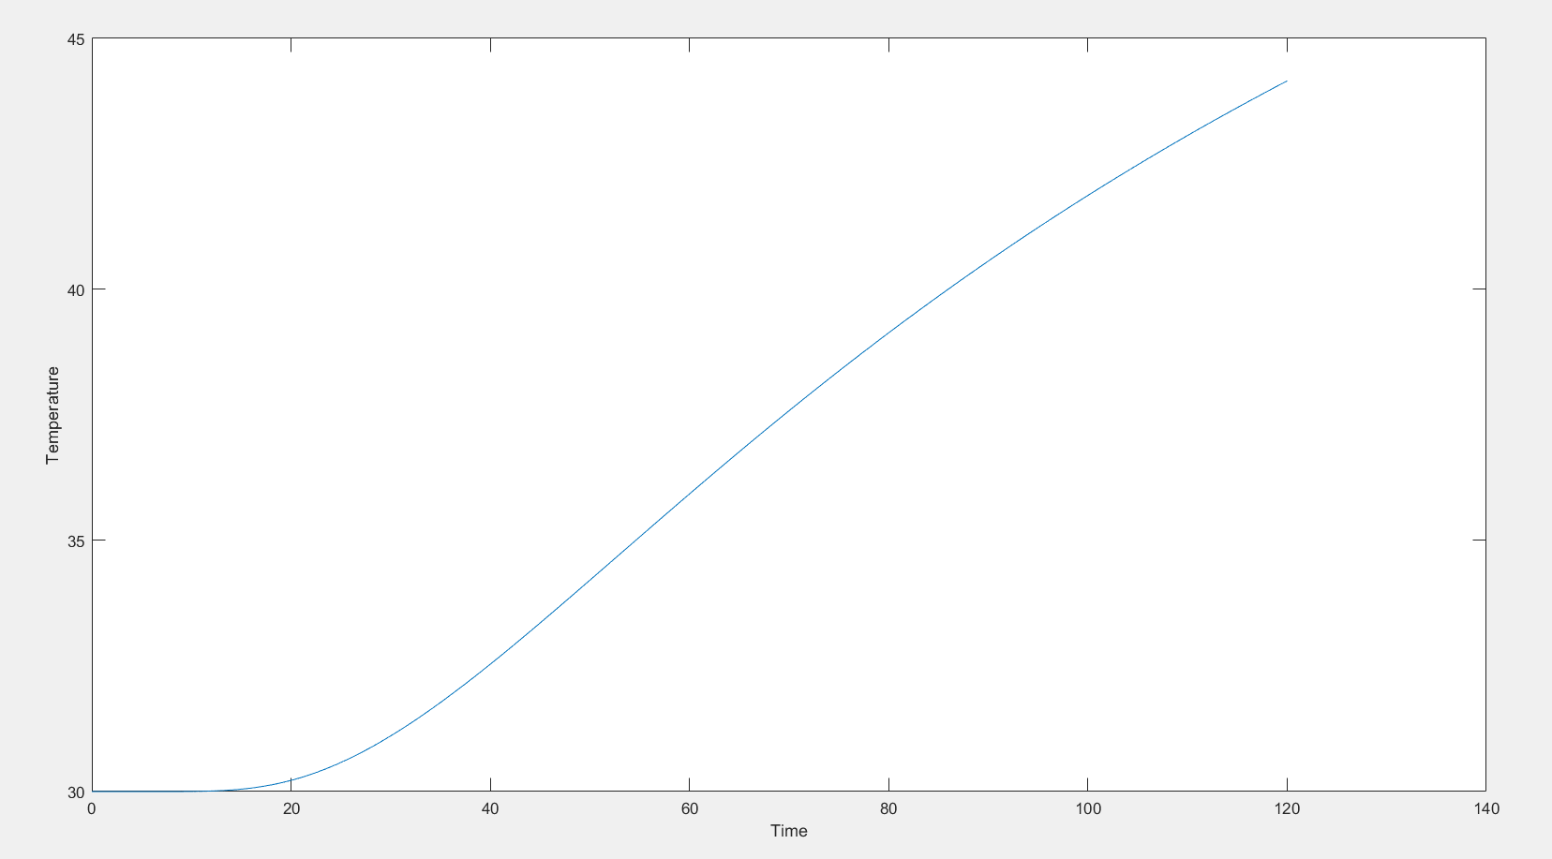

Case 4: Cast iron ; h = 1.172*10**(-5)

